**If any portno is showing busy**

<https://stackoverflow.com/questions/36601812/spring-boot-issue-while-running-the-spring-boot-app>

Follow steps to kill process on port

1] In command line interface

netstat -aon | find /i "listening"

2] Find port 8080 Ctrl+F and Enter 8080 (Port number of a process you want to kill)

3] Kill it's associated process id.

Taskkill /PID ProcessNumber /F

Taskkill /PID 3440 /F

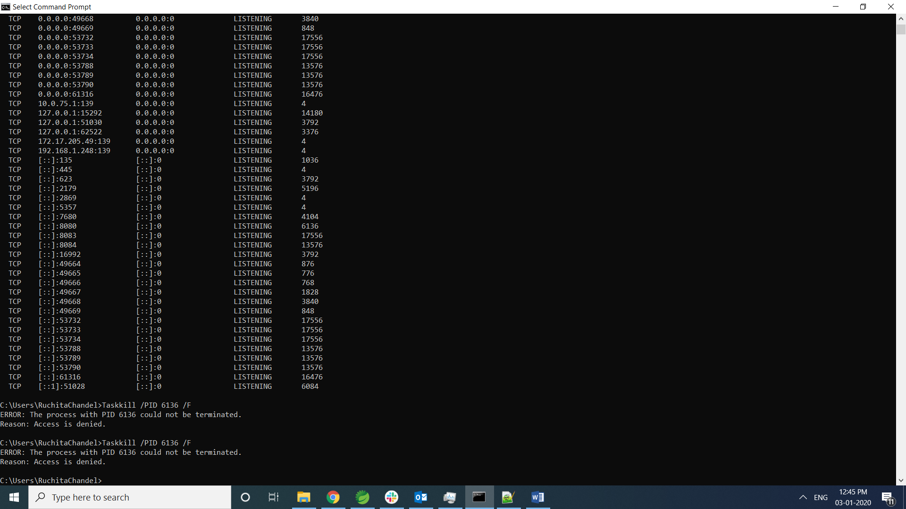

If you are not able to kill from here.

But u get PID

goto task manager -> In details search that pid and end that process by write click

